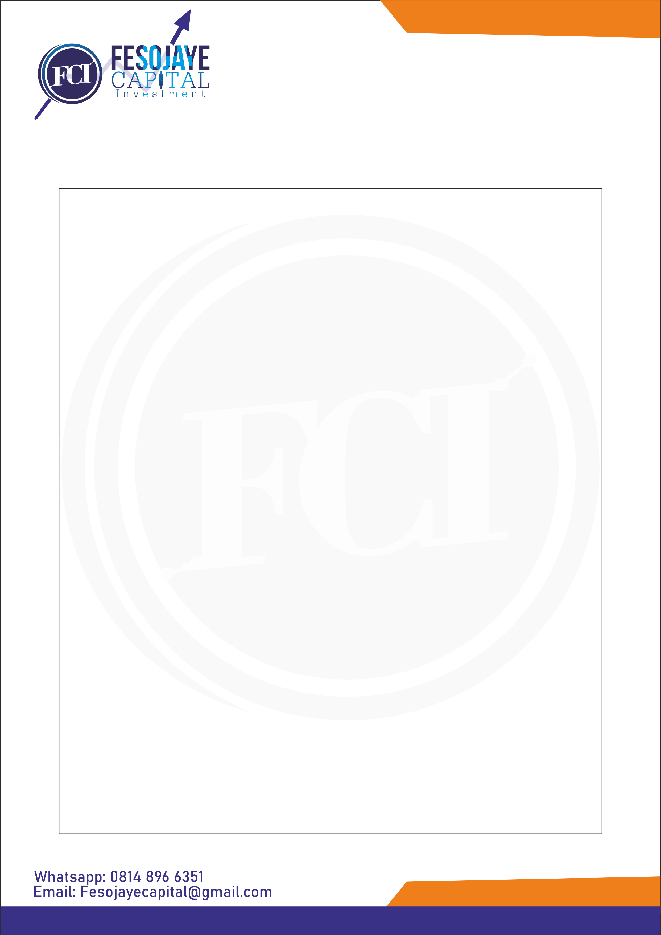**MEMORANDUM OF UNDERSTANDING**

This Memorandum of understanding is made and entered into on March 9, 2020 by and between Mr. Ogunyemi Luqman and Mrs. Ogunyemi Muhibat.

This MOU is intended to address additional compensation of 30% Return of Investment (**ROI**)for the investment worth Four Hundred Thousand Naira Only (₦400,000) made on this day by Mrs. Ogunyemi Muhibat.

This MOU provides for additional compensation in an amount equal to Five Hundred and Twenty Thousand Naira Only (₦520,000) for Mrs. Ogunyemi Muhibat to be paid on April 9, 2020.

*This MOU is valid as both parties mentioned above **AGREE** to the MOU.

